St MARYS CHURCH HIGHER BRIXHAM
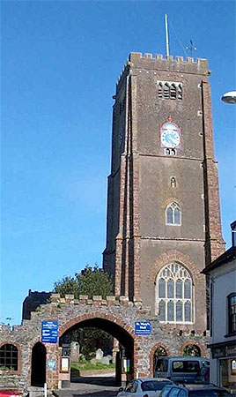
Cow Town’ St. Mary’s Project
In Support of the Church Tower Restoration Fund
A Talk/Slide Show
‘Old Brixham’
By Ivan Parton
Saturday October 6th 2018 In the Church Hall Starting at 2pm
Admission Adults £3.00 Children free
Refreshments Available Tickets on the door.
Supported by The Heritage Lottery Fund

